Practical No. 1
Aim : WAP to print a statement.
Name : Danish Altaf Solkar | Class : CO - B
Enrolment no. : 24111590805 | Batch : 2

Code :-
class hello
{
public static void main(String[] args)
{
System.out.println("\nHello MSBTE");

}
}

OUTPUT :-
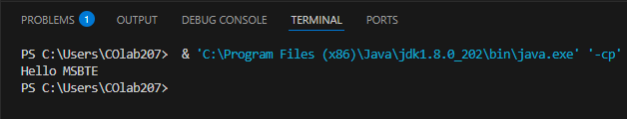

Process related  (5) | Product related  (10) | Total Marks  (25) | Signature

